**Top Pipette**

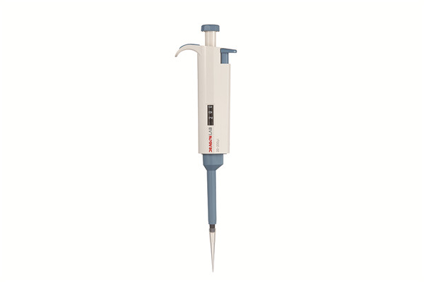

Features for TopPette

- Lightweight, ergonomic, low force design

- Digital display clearly reads volume setting

- The pipettes cover volume range of 0.1μl to 10ml

- Easy to calibrate and maintain with tool supplied

- Design helps avoid repetitive strain injuries

- Calibrated in accordance with ISO8655. Each pipette supplied with individual test certificate

- The low part is available for autoclaving

|  |  |  |  |  |  |  |
| --- | --- | --- | --- | --- | --- | --- |
| **Volume Range** | **Increment** | **Test Volume（μl）** | Accuracy error | | Precision error | |
|  |  |  | % | μl | % | μl |
| 0.1-2.5μl | 0.05μl | 2.5 | 2.50% | 0.0625 | 2.00% | 0.05 |
| 1.25 | 3.00% | 0.0375 | 3.00% | 0.0375 |
| 0.25 | 12.00% | 0.03 | 6.00% | 0.015 |
| 0.5-10μl | 0.1μl | 10 | 1.00% | 0.1 | 0.80% | 0.08 |
| 5 | 1.50% | 0.075 | 1.50% | 0.075 |
| 1 | 2.50% | 0.025 | 1.50% | 0.015 |
| 2-20μl | 0.5μl | 20 | 0.90% | 0.18 | 0.40% | 0.08 |
| 10 | 1.20% | 0.12 | 1.00% | 0.1 |
| 2 | 3.00% | 0.06 | 2.00% | 0.04 |
| 5-50μl | 0.5μl | 50 | 0.60% | 0.3 | 0.30% | 0.15 |
| 25 | 0.90% | 0.225 | 0.60% | 0.15 |
| 5 | 2.00% | 0.1 | 2.00% | 0.1 |
| 10-100μl | 1μl | 100 | 0.80% | 0.8 | 0.15% | 0.15 |
| 50 | 1.00% | 0.5 | 0.40% | 0.2 |
| 10 | 3.00% | 0.3 | 1.50% | 0.15 |
| 20-200μl | 1μl | 200 | 0.60% | 1.2 | 0.15% | 0.3 |
| 100 | 0.80% | 0.8 | 0.30% | 0.3 |
| 20 | 3.00% | 0.6 | 1.00% | 0.2 |
| 50-200μl | 1μl | 200 | 0.60% | 1.2 | 0.15% | 0.3 |
| 100 | 0.80% | 0.8 | 0.30% | 0.3 |
| 50 | 1.00% | 0.5 | 0.40% | 0.2 |
| 100-1000μl | 5μl | 1000 | 0.60% | 6 | 0.20% | 2 |
| 500 | 0.70% | 3.5 | 0.25% | 1.25 |
| 100 | 2.00% | 2 | 0.70% | 0.7 |
| 200-1000μl | 5μl | 1000 | 0.60% | 6 | 0.20% | 2 |
| 500 | 0.70% | 3.5 | 0.25% | 1.25 |
| 200 | 0.90% | 1.8 | 0.30% | 0.6 |
| 1000-5000μl | 50μl | 5000 | 0.50% | 25 | 0.15% | 7.5 |
| 2500 | 0.60% | 15 | 0.30% | 7.5 |
| 1000 | 0.70% | 7 | 0.30% | 3 |
| 2-10ml | 0.1ml | 10ml | 0.60% | 60 | 0.20% | 20 |
| 5ml | 1.20% | 60 | 0.30% | 15 |
| 2ml | 3.00% | 60 | 0.60% | 12 |

|  |  |  |  |  |  |  |
| --- | --- | --- | --- | --- | --- | --- |
| **Volume Range** | **Increment** | **Test Volume（μl）** | **Accuracy error** | | **Precision error** | |
|  |  |  | % | μl | % | μl |
| 5μl | - | 5μl | 1.3% | 0.065 | 1.2% | 0.06 |
| 10μl | - | 10μl | 0.8% | 0.08 | 0.8% | 0.08 |
| 20μl | - | 20μl | 0.6% | 0.12 | 0.5% | 0.1 |
| 25μl | - | 25μl | 0.5% | 0.125 | 0.3% | 0.075 |
| 50μl | - | 50μl | 0.5% | 0.25 | 0.3% | 0.15 |
| 100μl | - | 100μl | 0.5% | 0.5 | 0.3% | 0.3 |
| 200μl | - | 200μl | 0.4% | 0.8 | 0.2% | 0.4 |
| 250μl | -- | 250μl | 0.4% | 1.0 | 0.2% | 0.5 |
| 500μl | - | 500μl | 0.3% | 1.5 | 0.2% | 1.0 |
| 1000μl | - | 1000μl | 0.3% | 3.0 | 0.2% | 2.0 |
| 2000μl | - | 2000μl | 0.3% | 6.0 | 0.15% | 3.0 |
| 5000μl | - | 5000μl | 0.3% | 15 | 0.15% | 7.5 |